Crystal chemistry
Did you know?
About snow

Snowflakes are water ice crystals. They form in clouds when the temperature falls below 0 °C. Snowflakes will fall on land if the air temperature at ground level is also below 0 °C. Water molecules form a regular crystalline lattice based on a hexagon, so most snowflakes are six sided. Depending on the temperature and other conditions, the basic hexagon can grow into flat star shapes, or long columns and needles as shown. | 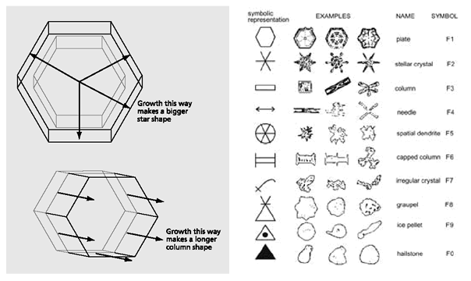 Figure 1 Growth of snow crystals Figure 2 Snow crystal classification

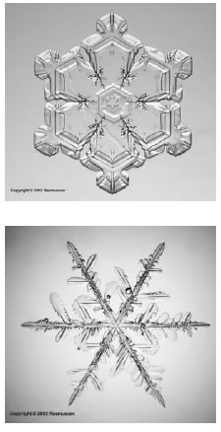 Snow crystals  Reproduced with kind permission from  Kenneth Libbrecht www.snowcrystals.net. | The classic star-shaped snowflakes are made at about  -15 °C. They form around a tiny dust particle. We learn from an early age that 'no two snowflakes are alike'. This was first suggested by a farmer called Wilson 'Snowflake' Bentley, who lived in Vermont in north east USA. He was born in 1865 and died in 1931. Bentley was the first person to photograph a snow crystal in 1885 and took about 5000 pictures of snowflakes in total during his lifetime. He said 'Under the microscope, I found that snowflakes were miracles of beauty; and it seemed a shame that this beauty should not be seen and appreciated by others. Every crystal was a masterpiece of design and no one design was ever repeated. When a snowflake melted, that design was forever lost. Just that much beauty was gone, without leaving any record behind.'  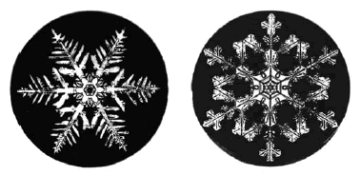  Wilson A. Bentley snow crystal photomicrograph  Reproduced with kind permission of Jericho (Vermont) Historical Society, www.snowflakebentley.com.
continued on next page

Crystal chemistry
continued from previous page
Questions
1. Is it true that 'no two snowflakes can be alike'? How could this be tested?
2. Use a model kit to make water molecules and investigate why snowflakes are usually hexagon-shaped.

